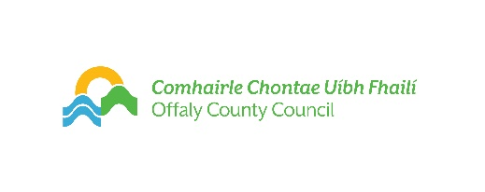
FILMOFFALY SHORT FILM AWARD 2024

APPLICATION FORM

An Application Form needs to be submitted with the script.
READ GUIDELINES CAREFULLY BEFORE COMPLETION.
Only one script per author.

Closing date 12 Noon Monday 11th March 2024

FilmOffaly Short Film Award, Arts Office, Offaly County Council, Aras an Chontae, Charleville Road, Tullamore, Co. Offaly

Details: (IMPORTANT PLEASE COMPLETE IN BLOCK LETTERS)
Applicant Name:
Applicant Address:

Telephone:
Mobile:
E-Mail: (Please Print Clearly)
Website:
Name of Script
Name of Writer/Writers
Contact of Writers (Tel or Mobile):

Production Company/Producer (If Known)
Name & Contact Number
Production Company Address (If Known)
Director and/or DOP (If known)

Type of Script | Short Fiction Short Documentary Experimental
Enclosed (Check List)
One application form
Two Copies of Script or Treatment (In case of documentary)
Two Copies of Synopsis
Check - Authors and production companies name omitted from Script & synopsis

Signed: Dated:

By submitting this application form to avail of Offaly County Council services, the applicant understands that Offaly County Council is committed to protecting the rights and privacy of individuals in accordance with Data Protection legislation and in line with the Council's Data Protection Policy:
https://www.offaly.ie/data-protection/

Important Notes: Please read the Guidelines carefully before submitting your script.
-Scripts will not be returned
-Applications will not be accepted after the deadline.
-All entries must be posted or delivered by hand. Not by e-mail.
-We do not accept CDs or removable drives.
- Please complete all sections of this application form. You will be notified by e-mail of decisions

